

CUSTOM BUILT SaaS THAT MOVES
YOUR BUSINESS.
Custom web apps, dashboards, booking & ordering systems, and internal tools —
fitted to how you work.

BUILT IN GEORGE · LIVE NOW

VERIDAX FORGE
Idea Validation
https://veridax.co.za

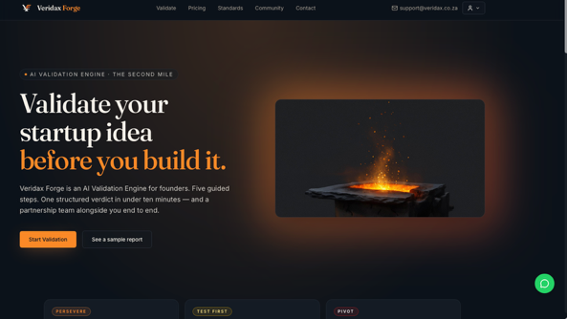

BUILDAPAIR
Cause-driven product launch &
storytelling.
https://buildapair.co.za



TYRE COMMAND
Fleet tyre management & tracking.
https://tyrecommand.com



Got a process slowing you down?
Let's build the fix.
francois@muverdelivery.co.za
Francois · 072 596 4689
www.muverdelivery.co.za
MUVER (Pty) Ltd · Reg 2017/422285/07
George, South Africa

SCAN TO VISIT

www.muverdelivery.co.za

